Case 5-Asia-China-Warring States Period-Bronze-Copper Sulfide-475 - 221 BCE

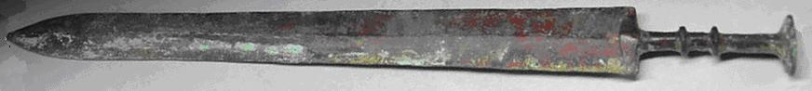
Asia-China-Warring States Period-Bronze-Copper Sulfide-475 - 221 BCE
Case No.: 5
Accession Number:
Formal Label: Asia-China-Warring States Period-Bronze-Copper Sulfide-475 - 221 BCE
Display Description:
Early Chinese bronze swords from the Warring States Period (475 - 221 BC) were made with high precision and often used advanced metallurgy. This 45.2 cm. long sword is of typical design and comes from the State of Chu. Many of these swords were coated with anti-corrosion protective layers, rumored to consist of a form of copper sulfide which on this example shows remnants of yellow residues.
Many ancient bronze artifacts have green patinas as does this sword which is typical of 2500 years of copper corrosion. The dark gray areas resemble the color of copper sulfides (chalcocite), which can range from dark gray to black. The tin rich alloys sometimes used for blades and anti-corrosive treatments can preserve a sword's sharpness for millennia. Swords that did not suffer heavy corrosion in the ground can be as sharp as a modern razor. This sword is very sharp and requires some care in handling.

LC Classification:
Date or Time Horizon:
Geographical Area:
The Warring States period was important in establishing peace in China. This sword comes from the state of Chu located in the south of China, with its core territory around the valleys of the Han River and, later, the Yangtze River.

Map:

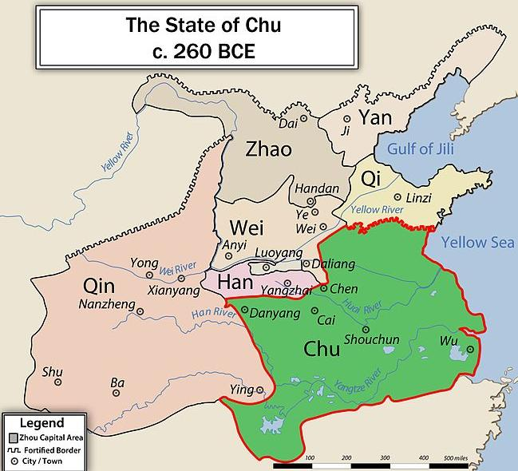
This map of the state of Chu is of the exact era when the Warring States sword was used to defend it by élite troops. Note the extent of the Great Wall that had already been erected by this time to protect China against the invaders from the north.
GPS Coordinates:
Cultural Affiliation:
Medium: bronze, copper sulfide as surface preservative
Dimensions:
Weight: 446 grams
Provenance:
Condition:
Discussion:
The five swords below are from the book Ba Shu Bronze Ware, which was compiled by the Provincial Museum of Sichuan. The sword on the left has turned completely black while the others have what appears to be a superficial protective layers. The sword on the top has the same blade design and same coloration as your sword.
INCLUDEPICTURE "../../../../Local%20Settings/Temp/scl11.jpg" \* MERGEFORMAT 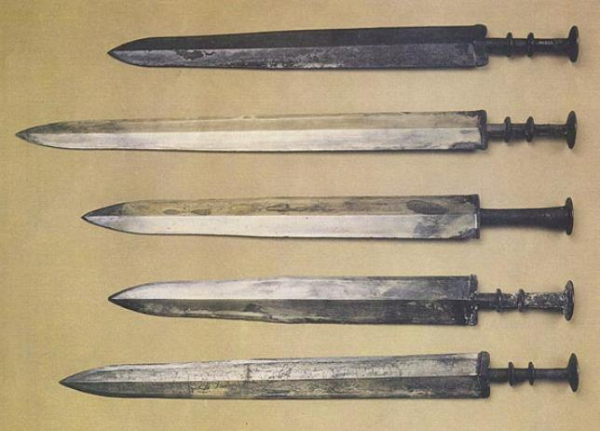
References:
Provincial Museum of Sichuan. 1992. Ba Shu bronze ware. Ba Shu qing tong ji. 巴蜀青铜器. Chengdu shi: Chengdu chu ban she.
Appendix:
The images below show this sword in various angles. In spite of their wide blades, these Warring States swords are relatively thin and well tapered making them light and well-balanced. This sword weighs 446 grams. The majority of the blades from the period also have a waist where the taper becomes more pronounced. This change in taper can be seen in the image below a little less than half way from the tip to the hilt.

